**Assignment 3: Perform Parsing of Family Tree Using Knowledge Base**

**Problem Statement**

Parsing a family tree using a knowledge base involves representing family relationships and performing queries to extract information based on predefined relationships and rules. A knowledge base (KB) stores structured information about individuals, their relationships, and other attributes.

**Objectives**

* To understand knowledge representation and reasoning in artificial intelligence.
* To use inference rules to parse and deduce relationships within a family tree.

**Theory**

**Knowledge Representation**

Knowledge representation is a key component of artificial intelligence, allowing entities (such as family members) and their relationships to be structured in a form that computers can process. This structured format enables reasoning, decision-making, and inference, which are essential for tasks like parsing family trees.

**Inference**

Inference is the process of deriving new information or relationships from existing facts using defined rules. In the context of a family tree, inference helps establish new relationships (e.g., cousins, aunts, uncles) based on known relationships (e.g., parent, sibling). This is done by applying logical rules to derive additional information not explicitly stored in the knowledge base.

**Methodology**

1. **Represent Family Members and Relationships**:
   * Use facts to represent family members and their direct relationships. For example, you might define facts like:
     + parent (John, Mary). (John is a parent of Mary)
     + parent (John, David). (John is a parent of David)
     + parent (Mary, Sara). (Mary is a parent of Sara)
2. **Define Rules for Inferring Relationships**:
   * Establish rules that define how to infer new relationships from existing ones. For instance:
     + sibling(X, Y) :- parent(Z, X), parent(Z, Y), X \= Y. (X and Y are siblings if they share at least one parent and are not the same person)
     + cousin (X, Y): - parent (A, X), parent (B, Y), sibling (A, B). (X and Y are cousins if their parents are siblings)
3. **Apply Rules to Infer New Relationships**:
   * Implement a reasoning engine that applies the defined rules to the facts in the knowledge base. This can be done using logic programming languages like Prolog or through custom implementations in Python.

**Working Principle / Algorithm**

Here’s a simple outline of the steps to parse the family tree:

1. **Input the Family Data**:
   * Populate the knowledge base with facts representing family members and their direct relationships.
2. **Define Inference Rules**:
   * Write rules that enable inference of new relationships (e.g., sibling, cousin).
3. **Query the Knowledge Base**:
   * Use queries to extract information about relationships. For example, asking for all siblings of a particular individual or identifying all cousins.
4. **Output Inferred Relationships**:
   * Display the relationships that have been inferred from the knowledge base.

**Advantages**

* **Complex Reasoning**: This method allows for advanced reasoning capabilities and the ability to deduce intricate relationships that may not be immediately obvious.
* **Flexibility**: The knowledge base can be easily modified or expanded to include more facts or rules.

**Disadvantages / Limitations**

* **Complexity**: As the family tree grows in size and complexity, managing and querying the knowledge base may become increasingly difficult.
* **Performance**: Inference over a large set of rules and facts can lead to performance issues, especially if the rules are not optimized.

**Diagram**

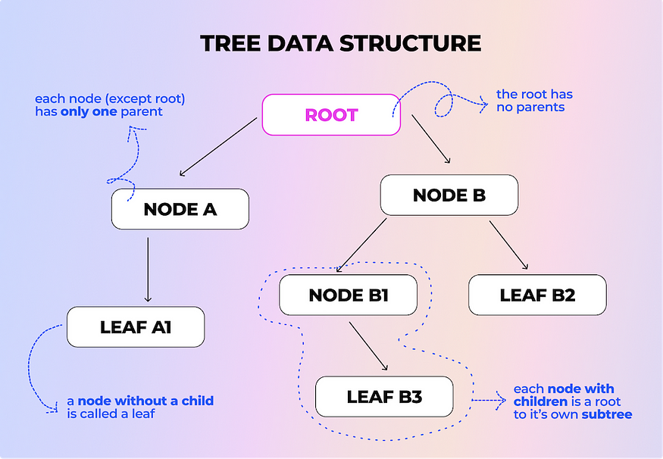

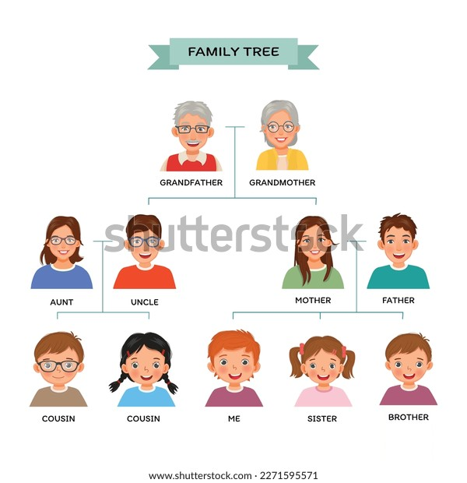

**Conclusion**

Using a knowledge base combined with inference rules provides a structured and effective way to parse and deduce relationships within a family tree. This approach enhances our ability to reason about familial connections, enabling a clearer understanding of the family structure.